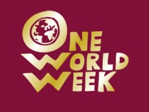
One World Week Quiz 2010
Peacing Together One World
TEAM NAME............................................................................................................
 | Answer | marks

Picture Round
1.
2.
3.
4.
5.
6.
7.
8.
9.
10.

TOTAL | /62

